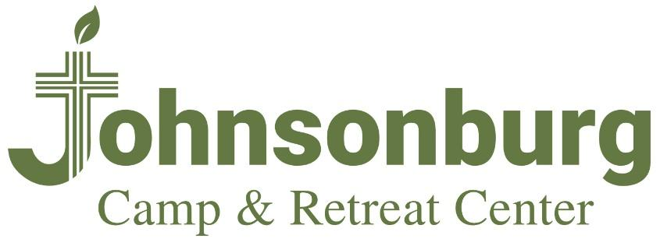
822 Route 519
Johnsonburg, NJ 07825
908-852-2349
www.campjburg.org

To transfer stocks, bonds or mutual funds as a donation to Johnsonburg Camp and Retreat Center, please provide your broker with the following instructions:

Please accept this letter as a request and authorization to execute the following securities gift transfer from account # (please provide your brokerage account number). Please deliver these shares to PNC Investments, LLC for further credit to Presbyterian Camps and Conferences, Inc. (Tax ID #22-1487356) as follows:
NFS and PNC Investments, LLC
FBO: Presbyterian Camps and Conferences, Inc.
DTC #0226
Account #005-197897
If your broker has any questions, please direct them to our Broker, Mike Ormond at 973-729-0227, and he will be able to assist with the transfer. Once these instructions are provided to our broker, the transfer of securities will be handled electronically and is typically completed within a day or two.
It is very important to Linda Thorstenson at linda@johnsonburg.org when transferring securities into this account so we may process your gift in a timely fashion. Additionally, please provide information on any designation you wish to make for your gift.
Thank you for your continuing support of the mission of Johnsonburg Camp and Retreat Center.

